PART A
(Part A: TO BE REFERRED BY STUDENTS)
Experiment No. 04
A.1 AIM:
To design Entity Relationship and relational model for the given case study.
A.2 Pre requisite:
Basic concepts of database, data models like ER-models and relational model.
A.3 Outcome:
After successful completion of this experiment, students will be able to

- Explain the basics of ER/EER Diagram and its importance in database design.
- Design ER diagram for the case study given.
- Convert the ER diagram into equivalent relational model.
- Enlist the difference between ER and Relational model.

A.4 Theory:
Summary of symbols used in ER notation:

Reduction of ER model to relational model:

Rules:

    - Build a table for each entity set

    - Build a table for each relationship set if necessary (depending upon cardinality)

    - Make a column in the table for each attribute in the entity set

    - Weak Entity Set Cannot exists alone

      - To build a table/schema for weak entity set

      - Construct a table with one column for each attribute in the weak entity set

      - Remember to include discriminator

      - Augment one extra column on the right side of the table, put in there the primary key of the Strong Entity Set (the entity set that the weak entity set is depending on)
      - Primary Key of the weak entity set = Discriminator + foreign key

Representation of relationship set:

For one-to-one relationship w/out total participation

    - Build a table with two columns, one column for each participating entity set’s primary key. Add successive columns, one for each descriptive attributes of the relationship set (if any).
For one-to-one relationship with one entity set having total participation

      - Augment one extra column on the right side of the table of the entity set with total participation, put in there the primary key of the entity set without complete participation as per to the relationship.
For one-to-many relationship w/out total participation

      - Same thing as one-to-one
For one-to-many/many-to-one relationship with one entity set having total participation on “many” side
      - Augment one extra column on the right side of the table of the entity set on the “many” side, put in there the primary key of the entity set on the “one” side as per to the relationship.
For many-to-many relationship

      - Same thing as one-to-one relationship without total participation.

      - Primary key of this new schema is the union of the foreign keys of both entity sets.
      - No augmentation approach possible

Representing composite attribute:

      - One column for each component attribute

      - NO column for the composite attribute itself

Representing multi-valued attribute:

- For each multivalue attribute in an entity set/relationship set

- Build a new relation schema with two columns
- One column for the primary keys of the entity set/relationship set that has the multivalue attribute
Representing Generalization\Specialization:

      - Two general approaches depending on disjointness and completeness

      - For non-disjoint and/or non-complete class hierarchy:

        - create a table for each super class entity set according to normal entity set translation method.
        - Create a table for each subclass entity set with a column for each of the attributes of that entity set plus one for each attributes of the primary key of the super class entity set
        - This primary key from super class entity set is also used as the primary key for this new table
      - For disjoint AND complete mapping class hierarchy:

        - DO NOT create a table for the super class entity set

        - Create a table for each subclass entity set include all attributes of that subclass entity set and attributes of the superclass entity set

A.5 Task to be completed in PART B:
A.5.1 Task1
Draw an ER diagram for given case study and convert it into relational model:

We need to create a database schema design based on the following (simplified) requirements of the COMPANY Database:
      - The company is organized into DEPARTMENTs. Each department has a name, number and an employee who manages the department. We keep track of the start date of the department manager. A department may have several locations.
      - Each department controls a number of PROJECTs. Each project has a unique name, unique number and is located at a single location.
      - There are two types of employees in company- technical employee and non-technical employee (administrative staff).
      - We store each EMPLOYEE’s Aadhar number, address, salary, sex, and birthdate.
      - Each technical employee works for one department but may work on several projects.

      - We keep track of the number of hours per week that a technical employee currently works on each project.
      - The technical employee gains score based on work done. The latest score of each technical employee is stored.
      - The non-technical employees are given incentives based on their work.

      - We also keep track of the direct supervisor of each employee.

      - Each employee may have a number of DEPENDENTs.

      - For each dependent, we keep track of their name, sex, birthdate, and relationship to the employee.

******************

PART B
(PART B: TO BE COMPLETED BY STUDENTS)
(Students must submit the soft copy as per following segments within two hours of the practical. The soft copy must be uploaded on the Blackboard or emailed to the concerned lab in charge faculties at the end of the practical in case the there is no Black board access available)
Roll No. : C172 | Name: Parva Gaglani
Class : D2 | Batch : D2
Date of Experiment : | Date/Time of Submission :
Grade :

B.1 Tasks given in PART A to be completed here
(Paste your answers and output here)
    - : Draw the ER diagram here
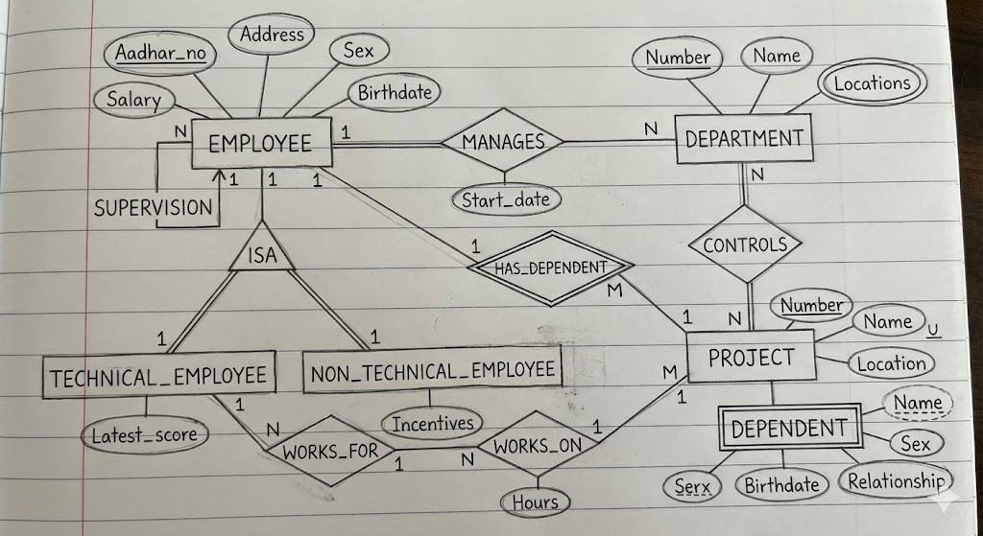
    - : Conversion of ER model into Relational Model:
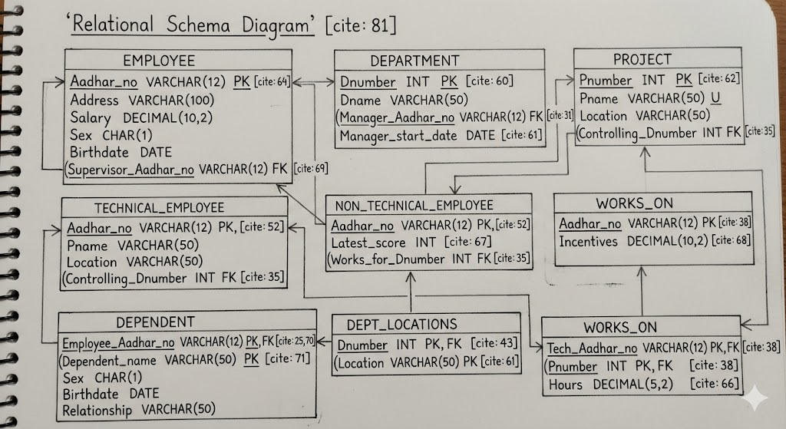

    - : Schema Diagram
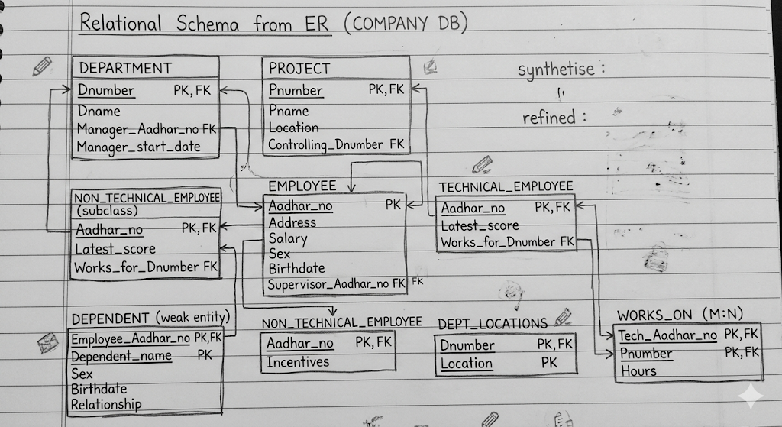
B.2 Conclusion:
(Students must write the observations and learning based on their understanding built about the subject matter and inferences drawn)

B.3 Question of Curiosity
(To be answered by student based on the practical performed and learning/observations)
Q1. Write your observation related to difference between ER model and Relational Model.
The ER (Entity Relationship) model and the Relational model are both used in database design but at different stages. The ER model is a high-level conceptual model used to visually represent the structure of a database using entities, attributes, and relationships. It is mainly used during the initial design phase to understand and plan how data is connected. It is represented using ER diagrams, which are easy to understand even for non-technical users. On the other hand, the Relational model is used to implement the database practically using tables. In this model, data is stored in relations (tables) consisting of rows and columns. The ER model acts as a blueprint, while the Relational model converts that blueprint into actual database tables with primary keys and foreign keys. Thus, the ER model is for design and understanding, whereas the Relational model is for implementation and storage.

Q2. Justify the statement, “The mistakes made in ER diagram badly affects the complete database design.”
The statement is true because the ER diagram forms the foundation of the entire database design. If mistakes are made in identifying entities, attributes, relationships, or cardinality, those errors will directly affect the relational tables created from it. Incorrect relationships may cause data redundancy or inconsistency. Wrong cardinality can restrict valid data entry or allow invalid data. Missing attributes may result in incomplete data storage, and incorrect keys may lead to poor database structure. Since the relational model is derived from the ER model, any error in the ER diagram gets carried forward into the database implementation. Correcting such mistakes later becomes difficult, time-consuming, and costly. Therefore, errors in the ER diagram can seriously impact the complete database design and its efficiency.

